User Acceptance Testing (UAT) Template
Date | 15 February 2026
Team ID | LTVIP2026TMIDS90862
Project Name | Prosperity Prognosticator: Machine Learning for Startup Success Prediction
Maximum Marks

Project Overview:
Project Name: Prosperity Prognosticator: Machine Learning for Startup Success Prediction
Project Description: A Machine Learning based web application that predicts whether a startup is likely to be Acquired or Closed based on input features. The system uses a Random Forest Classification model and is deployed using Flask framework.
Project Version: 1.0
Testing Period: [Start Date] to [End Date]
Testing Scope:
- Home Page Loading
- User Input Form Submission
- Prediction Generation (Acquired / Closed)
- Model Integration with Flask
- Result Display Page
Testing Environment:
URL/Location: http://127.0.0.1:5000
Credentials (if required): Not Required
Test Cases:
Test Case ID | Test Scenario | Test Steps | Expected Result | Actual Result | Pass/Fail
TC-001 | Verify Home Page Loads Successfully | Step 1: Open browser  Step 2: Enter application URL  Step 3: Press Enter | Home page should load successfully | Home page loaded successfully | Pass
TC-002 | Verify Prediction Output – Acquired | Step 1: Enter valid startup input details  Step 2: Click Predict button  Step 3: Observe prediction result | System should display prediction as “Acquired” | System displayed prediction as “Acquired” | Pass

Bug Tracking:
Bug ID | Bug Description | Steps to reproduce | Severity | Status | Additional feedback
BG-001 | No major functional bugs identified during testing | Not Applicable | Low | Closed | Application works as expected and predictions are displayed correctly.
Sign-off:
Tester Name: Project Team
Date: 15 February 2026
Signature:
Home Page: Prediction page: 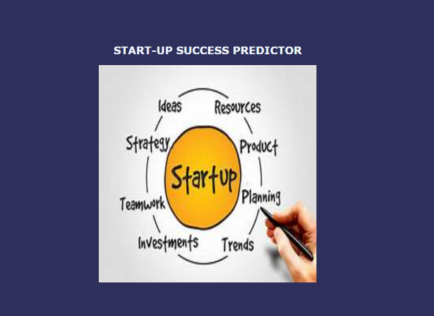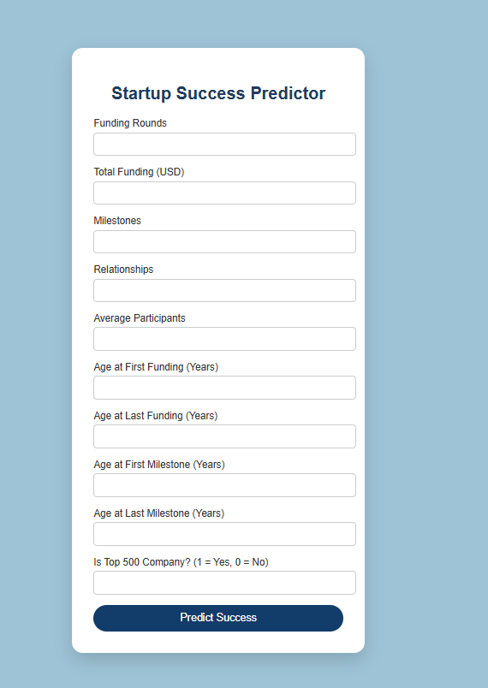
Results Page:
